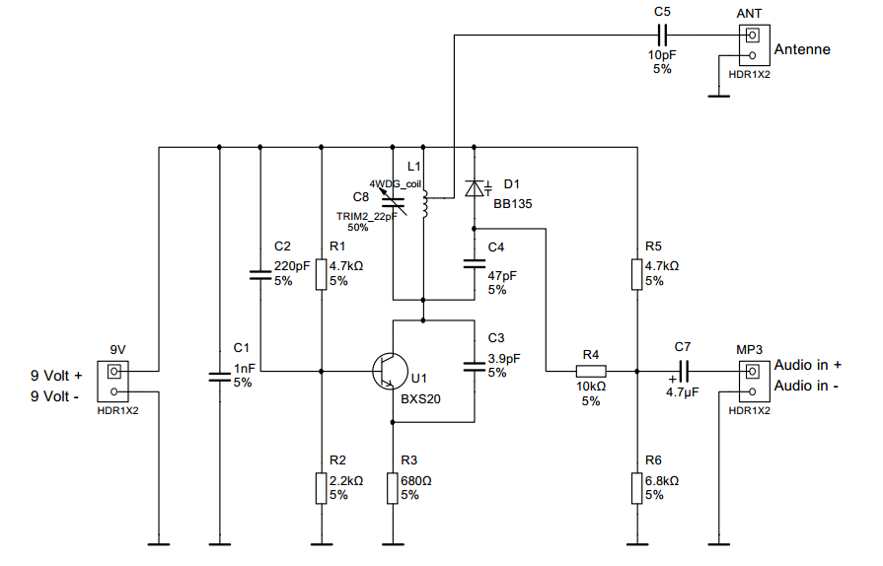
Quantity | Description | RefDes | Package | Type | Vendor | Vendor Part No.
1 | CAPACITOR, 1nF 5% | C1 | IPC-2221A/2222\CAPR254-500X310X650 | Ceramic | Farnell | 1216421
1 | CAPACITOR, 220pF 5% | C2 | IPC-2221A/2222\CAPR254-500X310X650 | Ceramic | Farnell | 1141767
1 | CAPACITOR, 3.9pF 5% | C3 | IPC-2221A/2222\CAPR254-500X310X650 | Ceramic | Farnell | 1694255
1 | CAPACITOR, 47pF 5% | C4 | IPC-2221A/2222\CAPR254-500X310X650 | Ceramic | Farnell | 2395776
1 | CAPACITOR, 10pF 5% | C5 | IPC-2221A/2222\CAPR254-500X310X650 | Ceramic | Farnell | 1694177
2 | RESISTOR, 4.7kΩ 5% | R1, R5 | IPC-2221A/2222\RES1300-700X250 | Carbon Film | Farnell | 9339540
1 | RESISTOR, 2.2kΩ 5% | R2 | IPC-2221A/2222\RES1300-700X250 | Carbon Film | Farnell | 9339302
1 | RESISTOR, 680Ω 5% | R3 | IPC-2221A/2222\RES1300-700X250 | Carbon Film | Farnell | 9339655
1 | RESISTOR, 10kΩ 5% | R4 | IPC-2221A/2222\RES1300-700X250 | Carbon Film | Farnell | 9339060
1 | RESISTOR, 6.8kΩ 5% | R6 | IPC-2221A/2222\RES1300-700X250 | Carbon Film | Farnell | 9339663
1 | CAP_ELECTROLIT, 4.7µF | C7 | IPC-2221A/2222\CAPPR200-500X1100 |  | Farnell | 1236668
1 | Transistor, BXS20 | U1 | Generic\TO-18 |  | Farnell | 9206876
1 | Cap, TRIM2_22pF | C8 | Ultiboard\TZC3P200A110B00 |  | Farnell | 9528652
1 | Varactor, BB135 | D1 | ON Semiconductor\SOD-323-2(CASE477-02H) |  | Farnell | 1349652
1 | Inductor, 4WDG_coil | L1 | Ultiboard\4WDG_coil |  | Homemade | 4x Winding, 6mm diameter, 1mm draad
3 | HEADERS_TEST, HDR1X2 | 9V, ANT, MP3 | Generic\HDR1X2 |  | Farnell | 1248176

Begroting per stuk:
- 9 Volt batterij: nemen de kinderen zelf mee
- 9 Volt batterijclip: Farnell 1650675 bij 25 stuks €0.921
- Header 1x2: Farnell 1248176 bij 50 stuks €0.147 (3 stuks)
- 1 nF Farnell 1216421 vanaf 5 stuks €0.187
- 220 pF Farnell 1141767 vanaf 5 stuks €0,119
- 2 x 4k7 (250 mW) Farnell 9339540 vanaf 50 stuks €0,0203
- 2k2 (250 mW) Farnell 9339302 vanaf 50 stuks €0.0203
- Trimmer Farnell 9528652 => vanaf 5 stuks €0.58
- T1 Farnell 9206876 => vanaf 25 stuks €1,10
- T1(alternatief) Farnell 9207120 (2n2222a), €0,852 va 25st)
- 680R Farnell 9339655 => vanaf 50 stuks €0.0207
- 3p9 Farnell 1694255 => vanaf 50 stuks €0.019
- L1 GRATIS
- 10pF Farnell 1694177 => vanaf 50 stuks €0.012
- BA141 wordt BB135 Farnell 1349652 => vanaf 5 stuks €0.0906
- 47pF Farnell 2395776 => vanaf 10 stuks €0.0218
- 10k Farnell 9339060 => vanaf 50 stuks €0.0203
- 6k8 Farnell 9339663 => vanaf 50 stuks €0,0208
- 4µ7 Farnell 1236668 => vanaf 25 stuks €0.0533
- 3,5mm jack voor MP3 Farnell
- Antennedraadje => GRATIS
- Printplaatje => ongeveer €0,70 vanaf 50 stuks bij pcbway.com
Met printplaatje ongeveer €4 per kind

